Barley and Mushroom Salad

Yield: 24 (4 ounce) servings

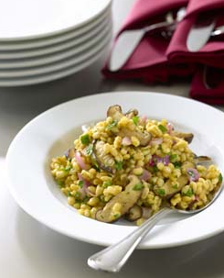
Vinaigrette
1½ ounces white wine vinegar
- tablespoon honey
- tablespoon brown mustard
4½ ounces olive oil
Salt and pepper

2 quarts water
3 ounces vegetable base
1 pound pearl barley
13 ounces shiitake mushrooms, raw, sliced
7½ ounces red onion, roasted, chopped
1½ ounces chopped fresh parsley
- tablespoon salt

Directions
For Vinaigrette: Whisk together vinegar, honey and mustard. Slowly add oil while whisking, until emulsified. Add salt and pepper to taste. (Makes about 7 ounces)

In a pot, mix together water with enough vegetable base to make a broth (follow manufacturer’s directions on quantity). Bring to a boil and add barley. Reduce heat and simmer, covered, until barley is tender (35 to 40 minutes). Drain any excess liquid, spread barley on a sheet pan to cool.

Sauté mushrooms in oil until tender. Mix sautéed mushrooms into cooled barley, along with onion, parsley, salt and Vinaigrette. Adjust seasoning as desired.

