Farmers Market Mushroom Salad

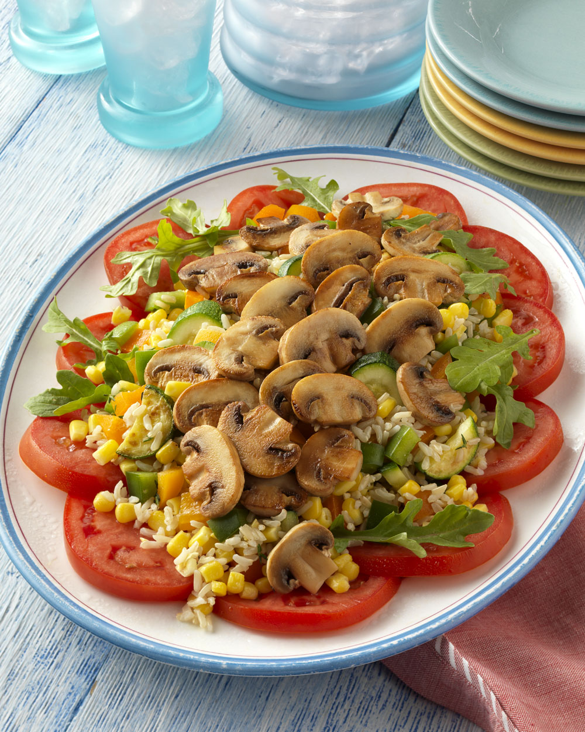
Makes 24 portions

Olive oil
3 pounds mushrooms, sliced
3 cups zucchini, chopped
6 cups fresh corn kernels
6 cups cooked brown rice
6 tablespoons fresh lemon juice
6 bell peppers of varying colors, diced
1½ cups fresh thyme leaves or 3 tablespoons dried
Salt and pepper to taste
6 beefsteak tomatoes, sliced
12 cups (12 ounces) arugula

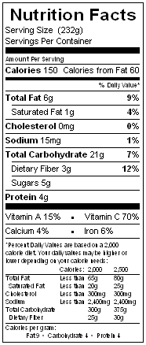
For each serving to order: Heat oil in a skillet over medium-high heat. Add 2 ounces mushrooms and cook, without stirring, until mushrooms become red-brown on one side. Turn ingredients and cook about until the other side is the same color. Set aside.

Sauté 2 tablespoons zucchini until just tender, adding additional oil to skillet if necessary. Turn off the heat and add 1/3 cup corn and 1/3 cup rice; stir to combine. Cook until warm. Drizzle with olive oil and 1 teaspoon lemon juice and gently stir in 1/3 cup bell pepper and 1 tablespoon fresh thyme (or a pinch of dried); season with salt and pepper to taste.

Arrange several tomato slices and 1/2 cup arugula on a plate; pour on the rice mixture and top with the mushrooms. May be served warm or cold.

