MUSHROOM FRIED RICE RECIPE
Mushroom Fried Rice is a popular Chinese cuisine. Learn how to make/prepare Mushroom Fried rice by following this easy recipe.
Difficulty: | Average | Rating: | 9.2
Recipe Type: | Veg.

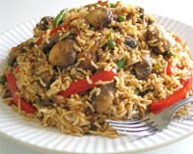
Ingredients:
• 1 Cup diced mushroom
• 1/2 Cup diced onions
• 1/4 Cup green peas
• 1 Tomato
• 1 Spoon chilly powder
• 1 Spoon coriander powder
• 5 cashews
• 1/4 Cup water
• Cooked rice
• Coriander chopped to garnish
• Salt to taste
• Oil as required
How to make Mushroom Fried Rice:
• | Heat oil in a wok.
• | Fry cashew nuts and onions. Then add mushrooms, chilly powder, salt, coriander powder, green peas and tomatoes.
• | Add water in it. Fry till oil separates from the mixture.
• | Then mix cooked rice and garnish it with chopped coriander leaves.
• | Mushroom Fried Rice is ready.

