Oyster Mushroom Kurma
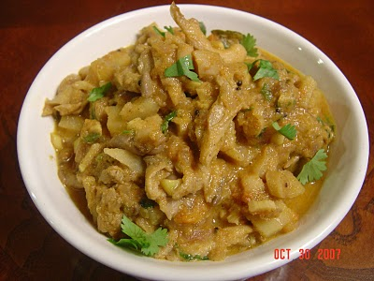Ingredients:
Oyster mushroom- 1 pack
cinnamon- 1" piece
cloves- 2
curry leaves- 1 twig
Onion- 1 (finely chopped)
ginger-garlic paste- 1tsp
green chillies- 5
Tomatoes- 2 (finely chopped)
red chilli- 1
jeera- 1tsp
saunf- 1 tsp
turmeric powder- 1/4 tsp
sambar powder- 1 1/2 tsp
garam masala- 1/4 tsp
coconut- 1/4 cup
corrinader leaves- small fistfull
water- 1 cup
salt- as required
Procedure:
Grind coconut to a smooth paste. Grind red chillies, jeera and saunf to a fine powder. Clean mushrooms by wiping off with a towel and seperate the stalks and the petals. Heat oil in a pan and fry the cinnamon and cloves. Then add onions, curry leaves, ginger garlic paste, green chillies and turmeric. Saute until golden brown. Then add tomatoes and cook till soft and mushy. Now add all the masala powders and mix well Saute for 5 mins or until the raw smell goes. Then add coconut paste and saute for 2 to3 mins. Now pour a cup of water and add required salt. Bring it to a boil. Now add the stalk portion of the mushrooms first. After 3 to 4 mins add the petals and cook it is soft and done. Garnish with corriander leaves. Goes really well with dosas.
